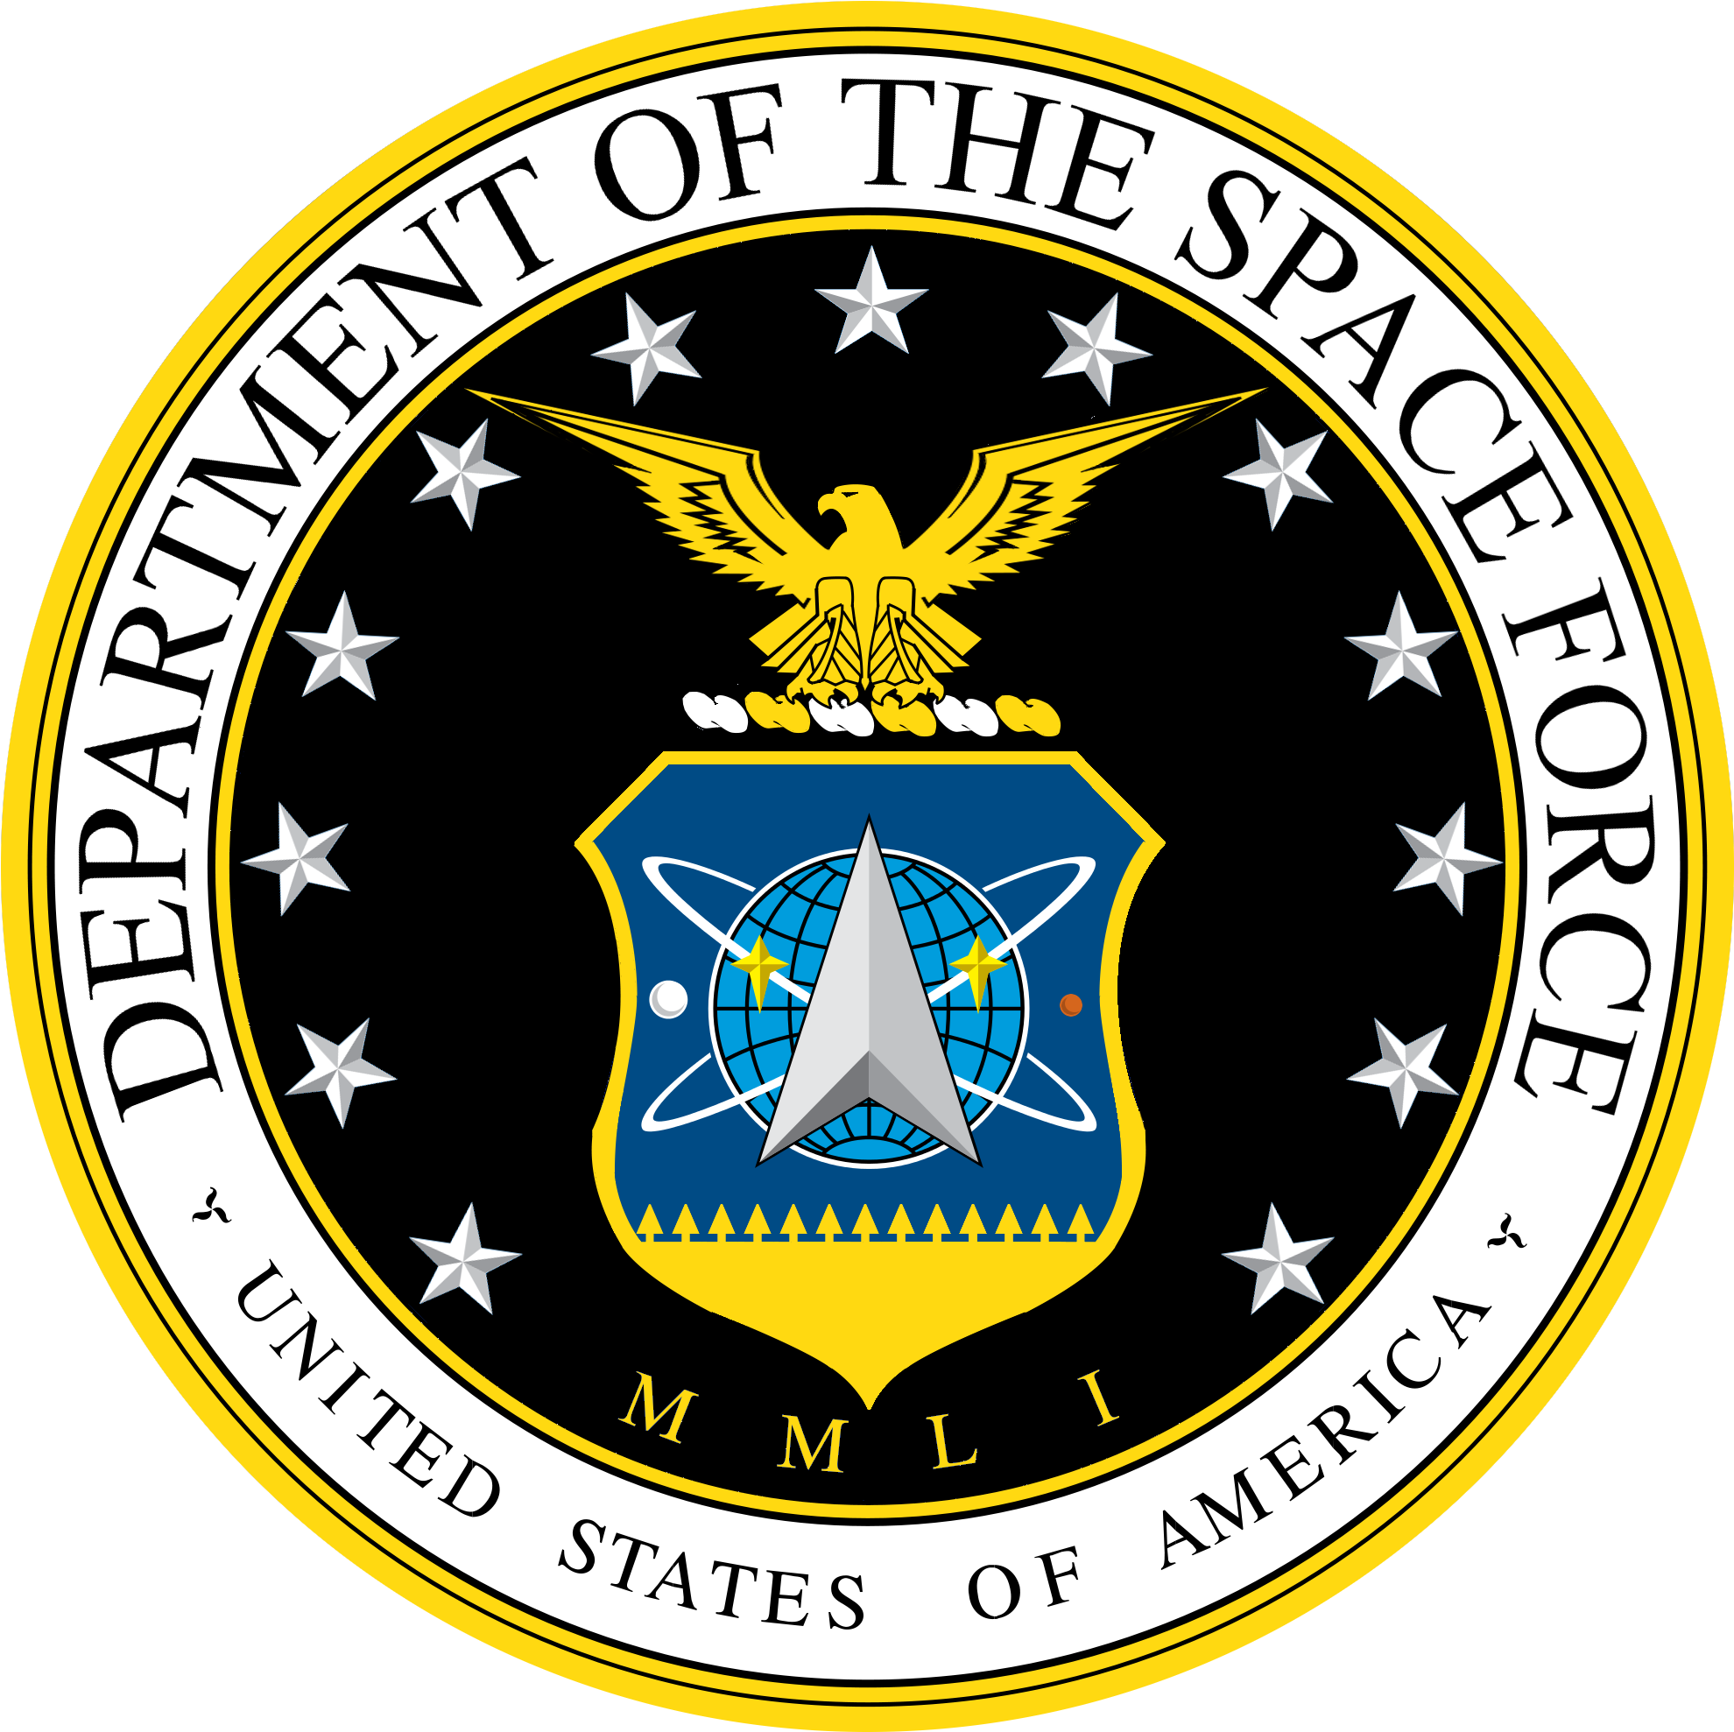
System Categorization Checklist
(A mock document created from NIST RMF publications for demo purposes)

System Identification
System Name | Public Affairs Storage Technology Asset (PASTA)
Version | 1.0
System Registration ID (Task P-18) | PASTA-1

General Description and Mission Processes Supported (Tasks P-8 & C-1)
Describe the missions, business functions, or processes this system will support.
This system includes
- Hosts: 5 laptops
- Networking technology: router, switch, and 2 wireless access points (WAPs)
- Server: 1 server providing network attached storage (NAS) services

This system is used by Super Space Force’s Public Affairs office (SSF/PA), <insert verbiage from publications about their responsibilities here>

Asset Identification (Task P-10)
Systems
Hardware
Software
Manufacturer | Title | Quantity | Version
Microsoft | Windows 11 Professional Edition | 5 | 22H1

Operational Status
X | Operational |  | Under Development |  | Major Modification

Information System Type
 | Major Application | X | General Support System

Authorization Boundary (Task P-11)

Control Overlays
Overlay Type | Yes | No
Intelligence: Does the system process, store, or transmit Intelligence data? | Intelligence Overlay | N/A
National Security: Does the system process classified information or considered a national security system? | Classified System Overlay | N/A
Mission Specific: Has a mission- or function-specific overlay been developed and mandated for this information type? | Mission-specific overlay | N/A
Privacy: Does the system process personally identifiable information (PII)? | Privacy overlay required | N/A

Information Life Cycle (Task P-13)
Privacy Impact Assessment (PIA) – Required for systems processing, storing, or transmitting PII.
DD Form 2930, Privacy Impact Assessment: https://www.esd.whs.mil/Portals/54/Documents/DD/forms/dd/dd2930.pdf
System of Records Notice (SORN) – According to the Privacy Act, the system will require a SORN published to the Federal Register if records within this system are retrieved by name or identifying criteria for individuals.
See more: https://www.federalregister.gov/documents/2024/05/15/2024-09967/privacy-act-of-1974-system-of-records

Information Types and System Categorization (Tasks P-12 & C-2)
Information Type | Low | Moderate | High
Final Security Categorization

System Stakeholders (Task P-9)
Identify RMF roles and stakeholders with an interest in the success of the system, covering the development, operation, and maintenance of the system.
Role | Name | Phone | Organization
Authorizing Official* | General Mark Naird | 904-452-1234 | SSC/CC
Security Control Assessor* | Nicholas Morrow | 710-134-2243 | SSC/SCA
Information System Owner
Program Manager* | Maj. Gen. James Jorge | 719-113-1234 | SSC/MA/CC
Information System Security Manager* | Ramon Dupree | 232-132-1993 | SSC/MA/MC-1
Information System Security Officer
System Administrator
User Representative
Information Owner
* Minimum RMF role requirements

